|  |  |  |  |
| --- | --- | --- | --- |
| JUMLAH PEMASUKAN | | | Rp. 9.780.000 |
| NO | TANGGAL | FOTO PRODUK | KUITANSI |
| 1. | 19 NOV 2024 | D:\LEMBATA\bukti prototype\ALAT\IMG_20241118_100405.jpg  Gilingan daging GSF  D:\LEMBATA\bukti prototype\ALAT\IMG_20241119_152924.jpg  Loyang 26 x 26  D:\LEMBATA\bukti prototype\ALAT\IMG_20241119_152611.jpg  Roll Kayu  D:\LEMBATA\bukti prototype\ALAT\IMG_20241118_095820.jpg  Parutan |  |

|  |  |  |  |
| --- | --- | --- | --- |
|  |  | D:\LEMBATA\bukti prototype\ALAT\IMG_20241118_095940.jpg  Ayakan  D:\LEMBATA\bukti prototype\ALAT\WhatsApp Image 2024-11-28 at 10.03.42.jpeg  Gelas Ukur  D:\LEMBATA\bukti prototype\ALAT\WhatsApp Image 2024-11-28 at 10.03.42 (1).jpeg  Masker Wajah  D:\LEMBATA\bukti prototype\ALAT\IMG_20241118_095952.jpg  Sapu tangan plastic |  |

|  |  |  |  |
| --- | --- | --- | --- |
|  |  | D:\LEMBATA\bukti prototype\ALAT\IMG_20241118_095911.jpg  Timbangan Digital  D:\LEMBATA\bukti prototype\ALAT\IMG_20241119_151448.jpg  Batre Alkaline  D:\LEMBATA\bukti prototype\ALAT\IMG_20241118_100055.jpg  Plastik Klip merah putih  D:\LEMBATA\bukti prototype\ALAT\IMG_20241118_100031.jpg  Cling Wrap  D:\LEMBATA\bukti prototype\ALAT\IMG_20241118_100135.jpg  Garam krista |  |

|  |  |  |  |
| --- | --- | --- | --- |
|  |  | D:\LEMBATA\bukti prototype\ALAT\IMG_20241118_100109.jpg  Plastik gula pasir  D:\LEMBATA\bukti prototype\ALAT\IMG_20241118_100146.jpg  Amanda Margarine  D:\LEMBATA\bukti prototype\ALAT\IMG_20241118_100124.jpg  Gula pasir kristal |  |

|  |  |  |  |
| --- | --- | --- | --- |
|  |  | D:\LEMBATA\bukti prototype\ALAT\IMG_20241118_100043.jpg  Maizenaku |  |
| 2. | 15 NOV 2024 | D:\LEMBATA\bukti prototype\ALAT\IMG_20241118_100428.jpg  Oven  D:\LEMBATA\bukti prototype\ALAT\WhatsApp Image 2024-12-02 at 11.18.24.jpeg  Loyang 30x30 | D:\LEMBATA\bukti prototype\KUITANSI\KUITANSI SCAN\WhatsApp Image 2024-11-25 at 18.04.16.jpeg |
| 3. | 19 N0V 2024 | D:\LEMBATA\bukti prototype\ALAT\WhatsApp Image 2024-11-28 at 10.03.38.jpeg  Kertas Roti | D:\LEMBATA\bukti prototype\KUITANSI\KUITANSI SCAN\WhatsApp Image 2024-11-25 at 17.09.40 (1).jpeg |

|  |  |  |  |
| --- | --- | --- | --- |
|  |  | D:\LEMBATA\bukti prototype\ALAT\IMG_20241119_152729.jpg  Pengalas adonan  D:\LEMBATA\bukti prototype\ALAT\WhatsApp Image 2024-11-28 at 10.03.32.jpeg  Kompor  D:\LEMBATA\bukti prototype\ALAT\IMG_20241119_152445.jpg  Chopper BMW  D:\LEMBATA\bukti prototype\ALAT\WhatsApp Image 2024-12-02 at 11.17.11.jpeg  Loyang 30x30 |  |

|  |  |  |  |
| --- | --- | --- | --- |
|  |  | D:\LEMBATA\bukti prototype\ALAT\WhatsApp Image 2024-11-19 at 17.33.29.jpeg  Minyak tanah 1,5 l  D:\LEMBATA\bukti prototype\ALAT\WhatsApp Image 2024-11-19 at 17.41.24.jpeg  Kocokan adonan  D:\LEMBATA\bukti prototype\ALAT\WhatsApp Image 2024-11-28 at 11.13.50.jpeg  Gilingan Halus |  |

|  |  |  |  |
| --- | --- | --- | --- |
| 4. | 20  N0VEMBER 2024 | D:\LEMBATA\bukti prototype\ALAT\WhatsApp Image 2024-11-28 at 11.44.57.jpeg  Air Galon |  |
| 5. | 21  NOVEMBER 2024 | tissue wajah paseo pink 250 sheets, Kesehatan & Kecantikan, Kulit, Sabun &  Tubuh di Carousell  Tissue kering | D:\LEMBATA\bukti prototype\KUITANSI\KUITANSI SCAN\WhatsApp Image 2024-11-25 at 17.09.39.jpeg |

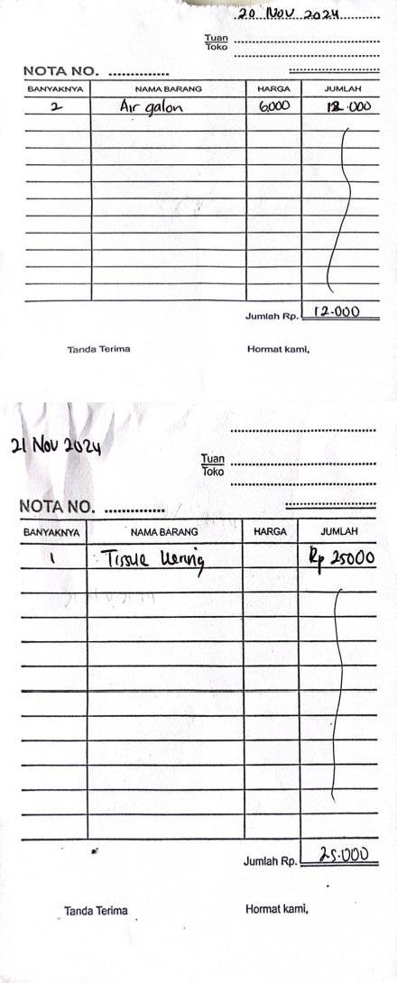

|  |  |  |  |
| --- | --- | --- | --- |
|  |  | D:\LEMBATA\bukti prototype\ALAT\WhatsApp Image 2024-12-04 at 12.55.35.jpeg  Minyak tanah  Tak perlu label "potensi BPA" pada galon AMDK terstandardisasi - ANTARA  News Nusa Tenggara Barat - Berita Terkini Nusa Tenggara Barat  Air galon | C:\Users\Miss Febry\Downloads\WhatsApp Image 2024-12-10 at 22.23.06.jpeg |
| 6. | 22  NOVEMBER 2024 | Kain Lap  D:\LEMBATA\bukti prototype\ALAT\WhatsApp Image 2024-11-28 at 10.03.39 (3).jpeg  Pisau | D:\LEMBATA\bukti prototype\KUITANSI\KUITANSI SCAN\WhatsApp Image 2024-11-25 at 17.09.31.jpeg |

|  |  |  |  |
| --- | --- | --- | --- |
|  |  | D:\LEMBATA\bukti prototype\ALAT\WhatsApp Image 2024-11-28 at 09.37.27.jpeg  Toples  Ubi kayu - Wikipedia bahasa Indonesia, ensiklopedia bebas  Ubi kayu  Jagung Popcorn Manisjagung Mentah Keringpopcorn 500 Gram Jagung  Jagung  D:\LEMBATA\bukti prototype\ALAT\WhatsApp Image 2024-11-28 at 12.10.12.jpeg  Baskom | D:\LEMBATA\bukti prototype\KUITANSI\KUITANSI SCAN\WhatsApp Image 2024-11-25 at 17.09.36.jpeg  D:\LEMBATA\bukti prototype\KUITANSI\KUITANSI SCAN\WhatsApp Image 2024-11-25 at 17.09.41.jpeg |

|  |  |  |  |
| --- | --- | --- | --- |
|  |  | D:\LEMBATA\bukti prototype\ALAT\WhatsApp Image 2024-12-02 at 11.07.12 (1).jpeg  Mika MMP  D:\LEMBATA\bukti prototype\ALAT\WhatsApp Image 2024-11-28 at 12.11.30.jpeg  Baskom Stainless  D:\LEMBATA\bukti prototype\ALAT\WhatsApp Image 2024-11-28 at 11.18.37.jpeg  Sendok  D:\LEMBATA\bukti prototype\ALAT\WhatsApp Image 2024-11-28 at 10.03.39 (2).jpeg  Pisau |  |

|  |  |  |  |
| --- | --- | --- | --- |
|  |  | D:\LEMBATA\bukti prototype\ALAT\WhatsApp Image 2024-12-02 at 10.41.00.jpeg  Standing pouch  D:\LEMBATA\bukti prototype\ALAT\WhatsApp Image 2024-11-28 at 10.03.40.jpeg  Lap  D:\LEMBATA\bukti prototype\ALAT\WhatsApp Image 2024-12-02 at 11.07.12.jpeg  Mika brownies |  |

|  |  |  |  |
| --- | --- | --- | --- |
| 7. | 29 November  2024 | Product image one two cups kantong teh celup kosong tea bag 100pcsKantong kosong untuk seduh teh, atau minuman beraroma lain di dalamnya, menikmati waktu bersantai dengan minuman menyegarkan pilihan Anda sepanjang hari.FITURKantung TehKantong ini dapat diseduh | D:\LEMBATA\bukti prototype\KUITANSI\KUITANSI SCAN\WhatsApp Image 2024-11-25 at 17.49.49.jpeg |

|  |  |  |  |
| --- | --- | --- | --- |
|  |  | Kantong the celup  D:\LEMBATA\bukti prototype\ALAT\WhatsApp Image 2024-12-02 at 11.07.10 (1).jpeg  Wings sabun colek |  |

|  |  |  |  |
| --- | --- | --- | --- |
|  |  | D:\LEMBATA\bukti prototype\ALAT\WhatsApp Image 2024-12-02 at 10.27.35 (1).jpeg  Minyak goreng  D:\LEMBATA\bukti prototype\ALAT\WhatsApp Image 2024-12-02 at 10.27.34.jpeg  Alkohol  D:\LEMBATA\bukti prototype\ALAT\WhatsApp Image 2024-12-02 at 11.07.13.jpeg  Standpouch  D:\LEMBATA\bukti prototype\ALAT\WhatsApp Image 2024-12-02 at 10.39.19.jpeg |  |

|  |  |  |  |
| --- | --- | --- | --- |
|  |  | Sarung tangan  D:\LEMBATA\bukti prototype\ALAT\WhatsApp Image 2024-12-02 at 10.27.37.jpeg  Stopmap batik  D:\LEMBATA\bukti prototype\ALAT\WhatsApp Image 2024-12-10 at 20.09.20.jpeg  Label  D:\LEMBATA\bukti prototype\ALAT\WhatsApp Image 2024-12-02 at 10.27.34 (1).jpeg  Cmc |  |

|  |  |  |  |
| --- | --- | --- | --- |
|  |  | D:\LEMBATA\bukti prototype\ALAT\WhatsApp Image 2024-12-02 at 10.27.36.jpeg  Kertas jasmin  D:\LEMBATA\bukti prototype\ALAT\WhatsApp Image 2024-12-02 at 10.27.37 (1).jpeg  Kertas stiker  Kertas origami Satu box pen  D:\LEMBATA\bukti prototype\ALAT\WhatsApp Image 2024-11-30 at 12.14.40 (1).jpeg  Dandang | C:\Users\Miss Febry\Downloads\WhatsApp Image 2024-12-10 at 22.23.05 (1).jpeg |

|  |  |  |  |
| --- | --- | --- | --- |
|  |  | D:\LEMBATA\bukti prototype\ALAT\WhatsApp Image 2024-12-02 at 11.07.11 (1).jpeg  Toples    Talenan  Manfaat Batang Serai Bagi Kesehatan Tubuh – Blog Info dan Berita  Daun Serai  C:\Users\Miss Febry\Downloads\WhatsApp Image 2024-12-02 at 10.27.45 (1).jpeg  Lengkuas  D:\LEMBATA\bukti prototype\ALAT\WhatsApp Image 2024-12-02 at 11.18.55 (2).jpeg  Ubi singkong |  |

|  |  |  |  |
| --- | --- | --- | --- |
|  |  | C:\Users\Miss Febry\Downloads\WhatsApp Image 2024-12-02 at 10.38.26 (1).jpeg  Bawang Merah dan bawang putih |  |

|  |  |  |  |
| --- | --- | --- | --- |
|  |  | C:\Users\Miss Febry\Downloads\WhatsApp Image 2024-12-09 at 18.03.35 (1).jpeg  Ikan kembung  Galon Besar | Galon Kemasan Isi Ulang | Galon 19L BATAM di  Anugrah_electronic_batam | Tokopedia  Galon |  |

|  |  |  |  |
| --- | --- | --- | --- |
| 8. | 30 November  2024 | Konsumsi  D:\LEMBATA\bukti prototype\ALAT\WhatsApp Image 2024-12-09 at 18.51.23.jpeg  Ewiti |  |

|  |  |  |  |
| --- | --- | --- | --- |
| 9. | 2 Desember  2024 | D:\LEMBATA\bukti prototype\ALAT\WhatsApp Image 2024-12-05 at 16.11.00.jpeg  2 Ladaku  C:\Users\Miss Febry\Downloads\WhatsApp Image 2024-12-11 at 08.01.45.jpeg  6 rantang jagung lokal |  |

|  |  |  |  |
| --- | --- | --- | --- |
| 10. | 3 Desember  2024 | D:\LEMBATA\bukti prototype\ALAT\WhatsApp Image 2024-12-04 at 10.26.07.jpeg  Ubi Gembili | C:\Users\Miss Febry\Downloads\WhatsApp Image 2024-12-11 at 08.45.39.jpeg |

|  |  |  |  |
| --- | --- | --- | --- |
| 11. | 4 Desember  2024 | C:\Users\Miss Febry\Pictures\Screenshots\Screenshot (23).png  Tepung Tapioka  Jual Minyak Tanah di toko CV TRISETYA MANDIRI | SIPLAH  Minyak tanah  D:\LEMBATA\bukti prototype\ALAT\WhatsApp Image 2024-12-04 at 13.00.24.jpeg  Ikan Cakalang |  |

|  |  |  |  |
| --- | --- | --- | --- |
| 12 | 5 Desember  2024 | D:\LEMBATA\bukti prototype\ALAT\WhatsApp Image 2024-12-05 at 16.12.11.jpeg  Saori saos siram  D:\LEMBATA\bukti prototype\ALAT\WhatsApp Image 2024-12-05 at 16.13.02.jpeg  Kaldu jamur |  |
| 13. | 6 Desember  2024 | C:\Users\Miss Febry\Downloads\WhatsApp Image 2024-12-11 at 08.01.48.jpeg  Pisang | C:\Users\Miss Febry\Downloads\WhatsApp Image 2024-12-09 at 18.44.24 (3).jpeg |

|  |  |  |  |
| --- | --- | --- | --- |
|  |  | C:\Users\Miss Febry\Downloads\WhatsApp Image 2024-12-11 at 08.01.48 (1).jpeg  Hair cap  C:\Users\Miss Febry\Downloads\WhatsApp Image 2024-12-11 at 08.01.48 (2).jpeg  Celemek  C:\Users\Miss Febry\Downloads\WhatsApp Image 2024-12-11 at 08.01.41.jpeg  Tissue  C:\Users\Miss Febry\Downloads\WhatsApp Image 2024-12-11 at 08.01.43.jpeg |  |

|  |  |  |  |
| --- | --- | --- | --- |
|  |  | Telur    Mambo amplop |  |

|  |  |  |  |
| --- | --- | --- | --- |
|  |  | Ikan cakalang,ikan bilis |  |

|  |  |  |  |
| --- | --- | --- | --- |
|  |  | Lem kertas |  |

|  |  |  |  |
| --- | --- | --- | --- |
| 14. | 7 Desember  2024 | C:\Users\Miss Febry\Downloads\WhatsApp Image 2024-12-07 at 18.09.26.jpeg  Air galon    Lem kertas    Giling jagung |  |

|  |  |  |  |
| --- | --- | --- | --- |
| 15. | 8 Desember  2024 | C:\Users\Miss Febry\Downloads\WhatsApp Image 2024-12-06 at 16.52.55 (1).jpeg  Ikan selar,ikan bilis    Konsumsi    Tepung tapioka |  |

|  |  |  |  |
| --- | --- | --- | --- |
|  |  | Tepung tapioka    Bawang putih    Bawang merah |  |

|  |  |  |  |
| --- | --- | --- | --- |
|  |  |  |  |

|  |  |  |  |  |  |
| --- | --- | --- | --- | --- | --- |
| 16. | 9 Desember  2024 | C:\Users\Miss Febry\Downloads\WhatsApp Image 2024-12-10 at 22.46.39 (2).jpeg  Korek api  C:\Users\Miss Febry\Downloads\WhatsApp Image 2024-12-10 at 22.46.40 (1).jpeg  Ewiti | | | C:\Users\Miss Febry\Downloads\WhatsApp Image 2024-12-09 at 18.29.17.jpeg |
| 17. | 10 Desember  2024 |  |  |  |  |
| Garam krista    Blue Band serbaguna | | |

|  |  |  |  |
| --- | --- | --- | --- |
|  |  | Ikan Bedug |  |
| TOTAL PENGELUARAN | | | Rp. 5.760.000 |
| SISA SALDO | | | Rp. 4.020.000 |

**DESA WAIENGA**

**Dokumentasi Kegiatan**

1. 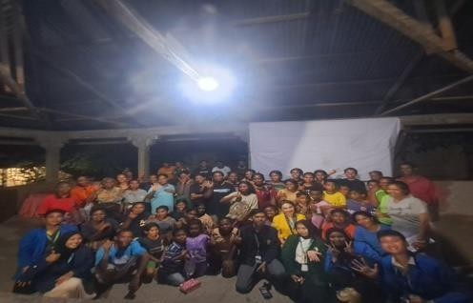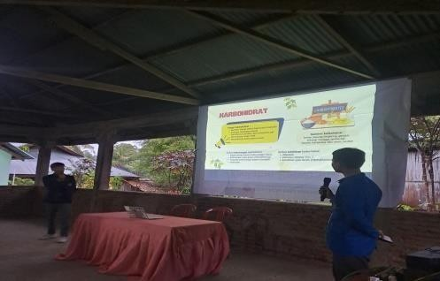Penyuluhan Gizi dan Penyuluhan Budidaya Gembili
2. 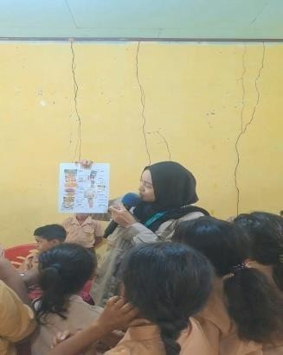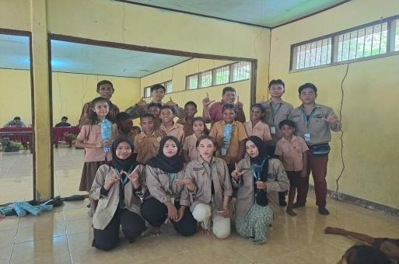*Sosialisa*si Gizi Pangan Lokal kepada Siswa SDK St. Wilhelmus Waienga
3. 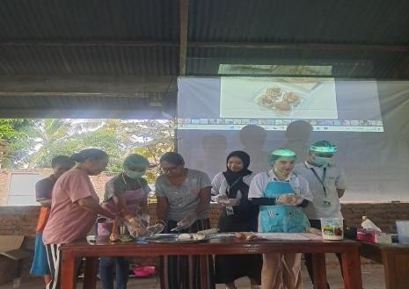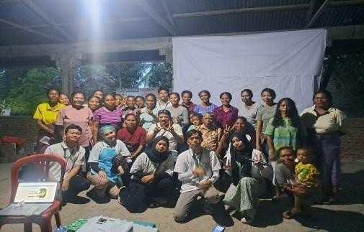Demo Prototype Bahan Pangan Lokal dan Pestisida Nabati MBKP Desa Waienga
4. Sosialisasi Stop Bullying pada Anak Sekolah Dasar

